Paul meets Jesus
Reading: from Acts 9:1-19
Meanwhile, Paul continued to oppose the Lord’s followers. He said they would be put to death. He asked the priests for letters to the synagogues in Damascus. On his journey, Paul approached Damascus. Suddenly a light from heaven flashed around him. He fell to the ground. He heard a voice speak to him, “Paul! Paul! Why are you opposing me?”
“Who are you, Lord?” Paul asked.
“I am Jesus,” he replied. “I am the one you are opposing. Now get up and go into the city. There you will be told what you must do.” Paul got up from the ground, but he couldn’t see. So they led him by the hand into Damascus. For three days he was blind. He didn’t eat or drink anything.
Then Ananias went to the house. He placed his hands on Paul. “Brother Paul,” he said, “you saw the Lord Jesus. He appeared to you on the road as you were coming here. He has sent me so that you will be able to see again. You will be filled with the Holy Spirit.” Right away something like scales fell from Paul’s eyes and he could see again. He got up and was baptised.

Thought about the reading
Paul was a hero who lived after Jesus had died and gone back to heaven. He was very important because God used him to take the good news about Jesus to people who were not Jews. He travelled all over the Roman Empire and started lots of churches. But he did not always follow Jesus. When he was a young man, he hated Christians, and wanted to see them all killed. He went around arresting them and throwing them in prison.
One day, he was on the way to a city called Damascus to arrest more Christians when Jesus appeared to him. Paul realised that he had been doing wrong. He decided to turn away from his old life and follow Jesus.
Jesus called Paul to do a special job. He calls us, too, and has a special job for each of us to do. He wants us to turn away from our old lives and follow him.

Prayer
Dear Jesus, I want to follow you like Paul. Please help me to turn away from my old life and do the things you have called me to do.

Amen

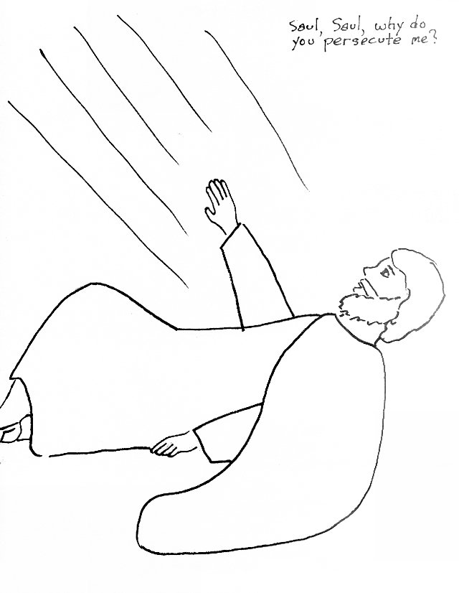
Paul meets Jesus

Cambridge Causeway

Summer 2024
Bible Study notes

Heroes of the Bible Part 2
6. Paul meets Jesus
By Chrissy Cole

